CA Bundles With ORM stack

Contents

1. Introduction 3
2. Workflow diagram to deploy the stack 3
3. Create stack for CA Bundles 4
4. Plan the Job 5
5. Apply the Job 6
6. Verify in the Console 8
7. Destroy the stack 8

Introduction

CA Bundle is a file that contains root and intermediate certificates. The end-entity certificate along with a CA bundle constitutes the certificate chain. A CA bundle can include a single CA or multiple CAs, including those not managed by the Certificates service. The Certificates service supports certificate content in PEM format.

Workflow diagram to deploy the stack

Below diagram shows how the Terraform Artifact are applied in the OCI. While creating a ORM stack, using terraform deliverables Init, Plan and Apply is the flow to provision the resource in the OCI. We can have the deliverables in any of below.

- GitLab/GitHub Repo
- Bitbucket
- Can be in folder/.zip in the local disk
- Object Storage Bucket
- Can be in compartment
- Oracle provided Template

Prerequisite
- Generate OCI certificate PEM file

Create stack for CA Bundles

Go to OCI Console Developer Services Resource Manager Stacks select the compartment Create Stack

My Configuration Folder Browse Select the “CA Bundles” folder that contains the terraform Upload

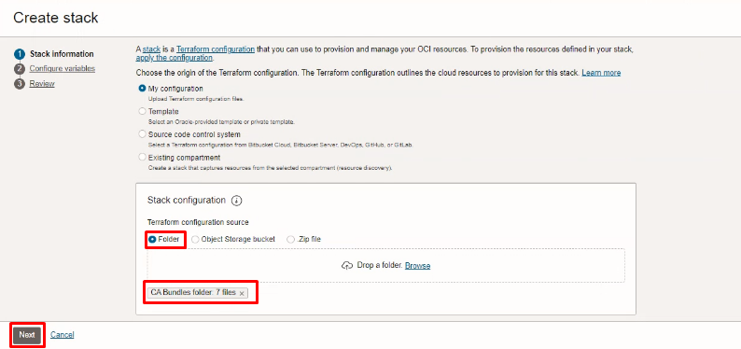

Select the parameters as per the below screen,
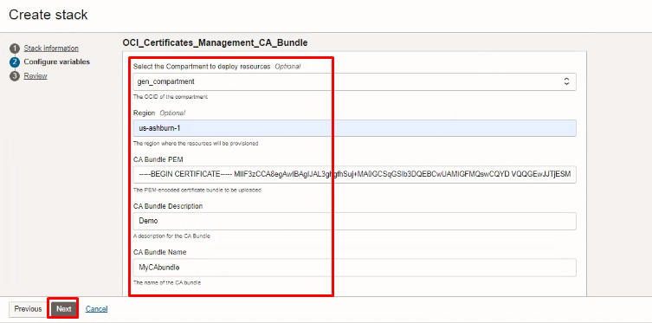
Click “NEXT”

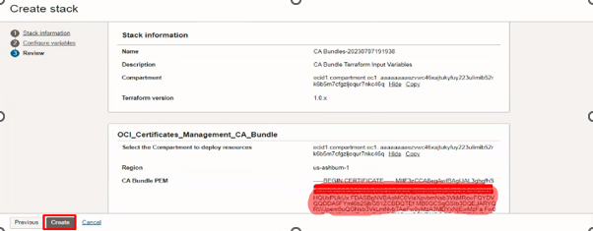
Click “CREATE”

Plan the Job

Click the “Plan”
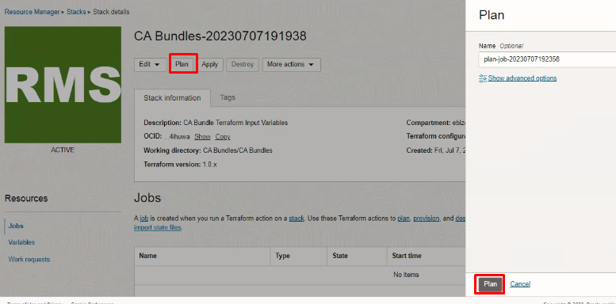
Verify the Plan is successful.

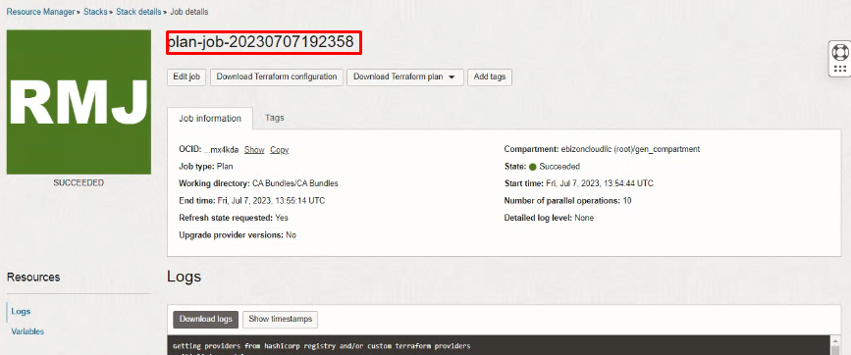
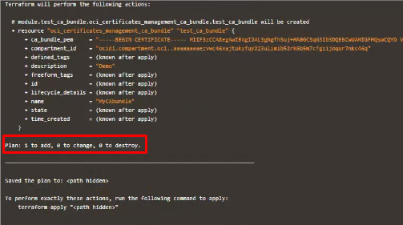

Apply the Job

Once the “plan” is success, now click “Apply”
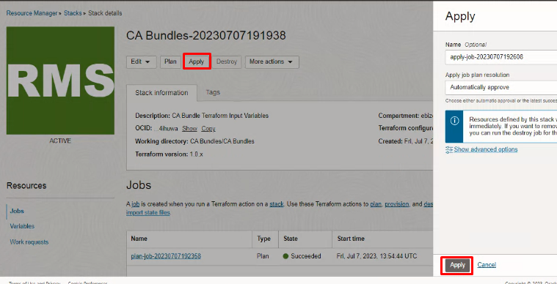
Verify the Apply is successful.

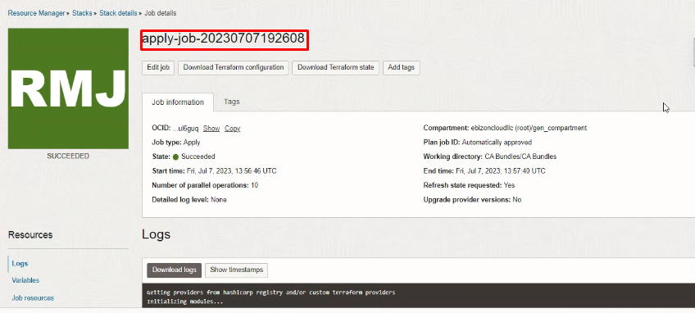
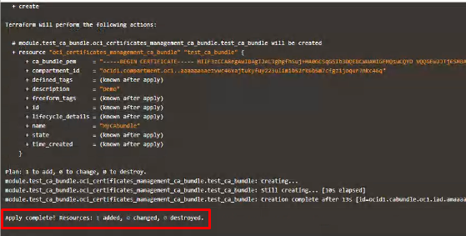

Verify in the Console

Go to OCI Console Identity and Security Certificates CA Bundles

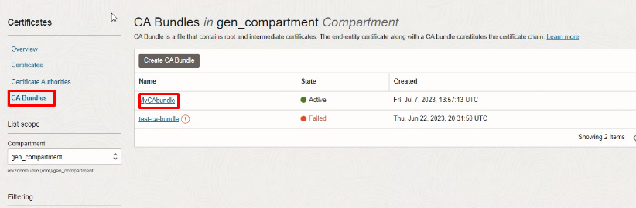

Certificates CA Bundles CA Bundles Details

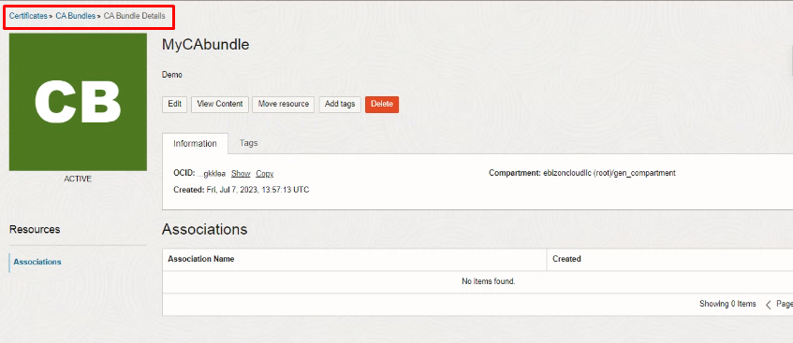

Destroy the stack

Create a destroy job in Resource Manager to release resources associated with a stack and clean up the tenancy. Once destroyed data cannot be recovered from resources.

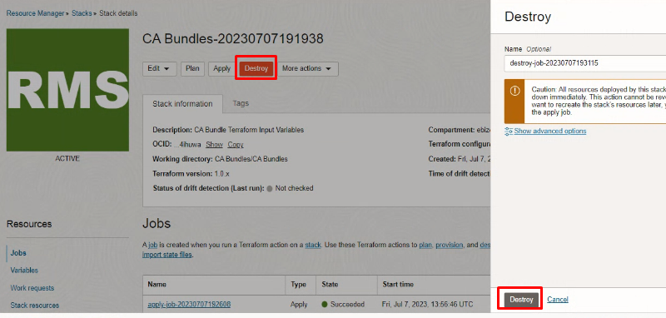

#END#

